**Dynamic Programming**

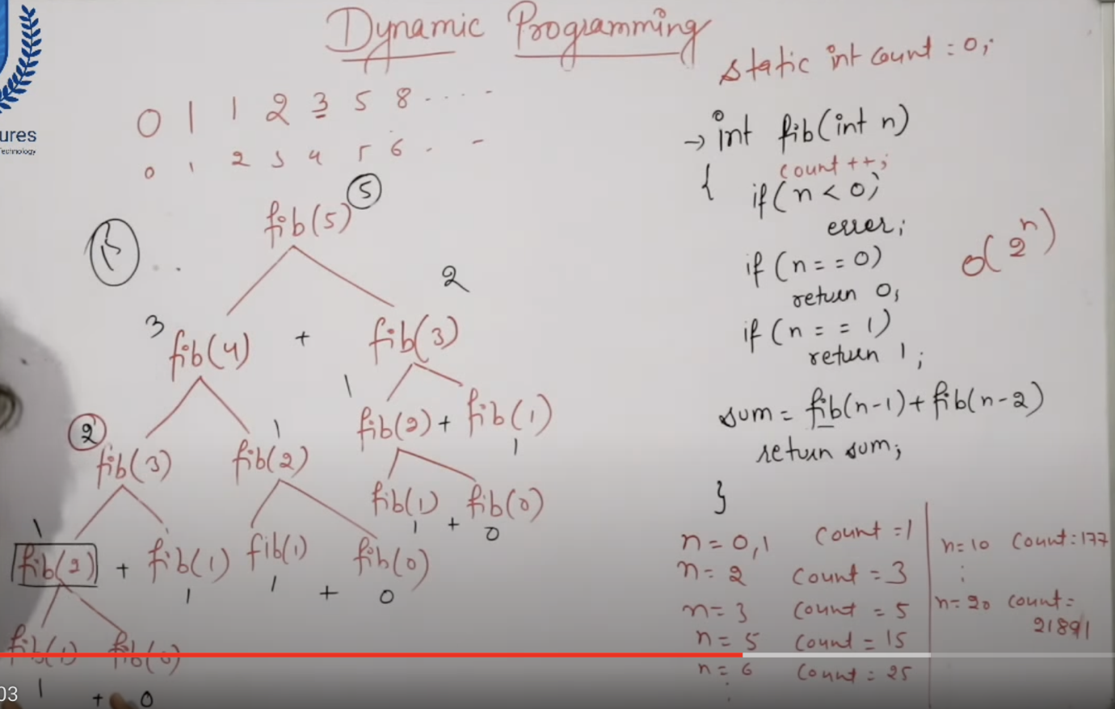

The Fibonacci series can be found using the recursion method with a time complexity of **O(2^n)**  and space complexity of T(N).

Dynamic programming method to find the Fibonacci series has the space complexity of **O(n)**

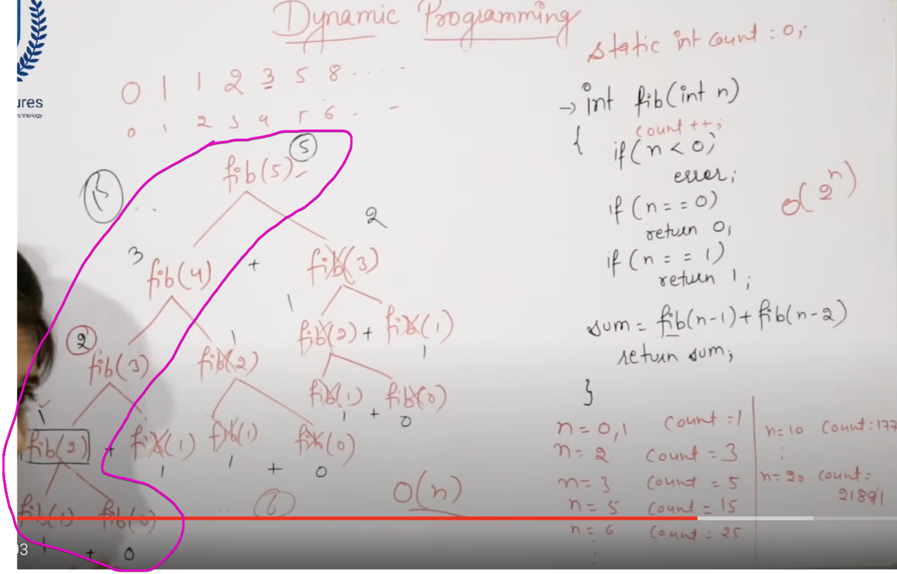

Since already fib(3) on LHS is calculated, since we can store the result of fib(3). This fib(3) result can be used on RHS. So that don’t want to recompute this again and again.

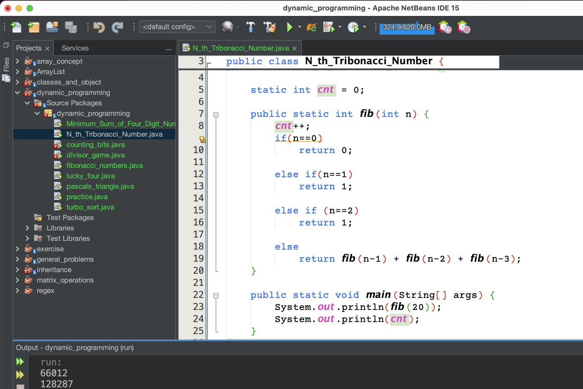

For Trifibonacci(20), we are making 128287 calls.

# Memoization Technique

# 

# 

# 